AccessUBC Project Site – FAQ

- What is AccessUBC?
AccessUBC manages access permissions for Staff and Faculty at UBC.
- How does AccessUBC impact UBC IT services and the people using them?
- Existing access privileges for employees and contractors will not change
- New employees and contractors will be provisioned EAD and ELDAP ‘normal’ accounts.
- Existing employees without an EAD account that have a CWL, will be given an EAD account

- The existing process for requesting services from individual service owners (e.g. FASmail, VDI etc.) via Service Catalog and Service Now will not change, and should be followed when requesting services for new and existing UBC IT employees and contractors.
- Future tracks will see a phased integration with more UBC IT services, departments, and systems of record on-boarded to AccessUBC based on timelines set by IAM Governance and UBC IT Senior Management Team.

- Who will use AccessUBC?
In Phase 1, AccessUBC will be used by Senior Help Desk staff, Desktop Services, and the IAM team.
In future phases, AccessUBC will be used by UBC managers and their delegates or team leads, Senior Help Desk staff, Desktop Services, and the IAM team.
- What are the steps for onboarding a new employee to UBC IT?
- Employee Submits Accepted Offer Letter (Local HR)
- Employee Record Created (Early ID System/HRMS)
- Employee Associates Employee ID with CWL Account (CWL myAccount)
- Employee Receives ‘CWL Account Activation’ Email (CWL myAccount)
- Identity Cube Auto-Created for Employee (AccessUBC)
- Base Service (EAD and ELDAP Normal Accounts) and Business Roles Auto-Provisioned to Employee (AccessUBC)
- Employee Receives ‘Welcome to UBC IT - Change CWL Password’ Email (AccessUBC)
- Employee Updates Password – stored in EAD and ELDAP (CWL myAccount/CWL Management Service)
- Manager Requests Other Services from Service Owners (Existing Service Now Process)
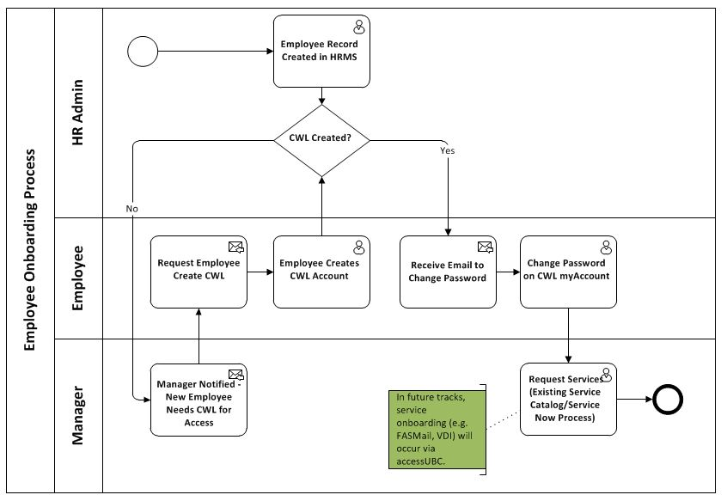
- How has the employee onboarding process changed?
- Employee does not select a Primary CWL Account in CWL myAccount. Employee has one CWL account in AccessUBC.
- Employee is auto-provisioned base services – EAD and ELDAP Normal and business roles (membership to) for their department.
- Employee must associate their CWL with their Employee ID via CWL Sign up (or the HR Portal) to be eligible for auto-provisioning.
- Employee provides personal email when CWL Account is created. Email validated as part of CWL Account Activation.
- Employee must update password in CWL myAccount - needed in AccessUBC Pilot to safely capture and store password in EAD and ELDAP. Update request sent via “Welcome to UBC” email.

- How has the contractor onboarding process changed?
- The workflow for onboarding contractors to UBC has not changed. In future releases there will be a new simplified contractor workflow.

- Can I still use my CWL Login to access UBC IT resources and services?
Yes. Your CWL Login and Password is still used to access resources and services.
Each employee will only have one CWL account in AccessUBC. If an employee has only one CWL account, then this CWL account is designated as the person’s primary account.
If the employee has multiple CWL accounts, the following rules apply:
- If an employee has already selected a Primary CWL Account, this account will be used.
- if an employee has not selected a Primary CWL Account, the CWL accounts used for the HR Portal will be the person’s primary CWL account.
- CWL Admin accounts will not be managed within AccessUBC at this time.

- Where do I update my CWL Login and Password?
CWL passwords are updated in CWL myAccount. There is no change to this process.
CWL Logins can be updated by a CWL Administrator. Please contact Help Desk. This process is also unchanged.

